Summary of Attend Anywhere

Table of Contents
1. Updates 1
2. Patient Satisfaction 2
2.1 Age groups 2
2.2 Per Year 2
2.3 Department 3
3. Comments 4
3.1 Most common words 4
3.2 Most frequent phrases 4
4. Values 5

Updates
This is a summary of patient satisfaction to attend anywhere. All figures are based on overall patient satisfaction only. Satisfactory levels have been grouped as either ‘Satisfied’ (Satisfied and Very Satisfied), ‘neutral’ and ‘Dissatisfied’ (Dissatisfied and Very Dissatisfied).

Patient Satisfaction

Age groups

Figure 1: Overall patient satisfaction to Attend Anywhere across different age groups

Per Year

Figure 2: Overall patient satisfaction to Attend Anywhere across different years. Looking at all sites combined (left) and site specific (right). AUH = Aintree, RLH = Royal Liverpool University Hospital and BGH = Broadgreen.

Department

Figure 3: Overall patient satisfaction to Attend Anywhere across different departments across different sites

Comments

Most common words
Figure 4: List of most frequently used words found in the comments of “Satisfied” (left) and “Dissatisfied” (bottom) patients across all sites.

Most frequent phrases

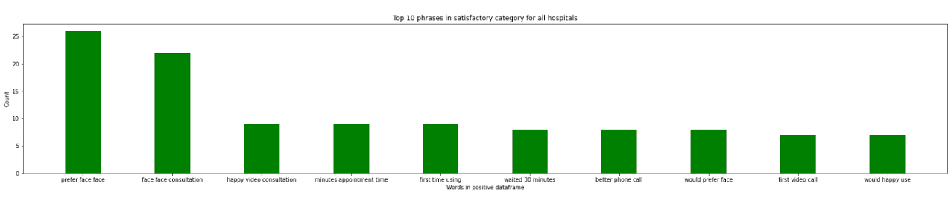
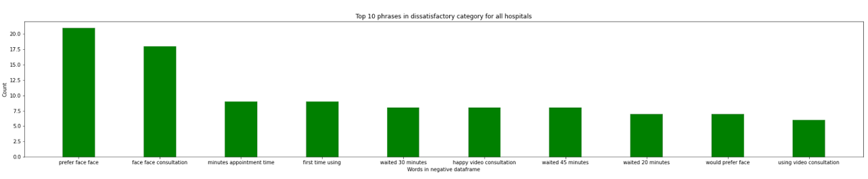
Figure 5: List of most frequently used phrases found in the comments of “Satisfied” (top) and “Dissatisfied” (bottom) patients across all sites.

Values
Table 1: Distribution of number of patients using Attend Anywhere across different sites and years
Region | 2020 | 2021 | 2022 | Total
AUH | 808 | 770 | 193 | 1771
BGH | 106 | 235 | 254 | 595
RLH | 975 | 2800 | 757 | 4532
Total | 1932 | 3847 | 1206 | 6985

